23.85: a) 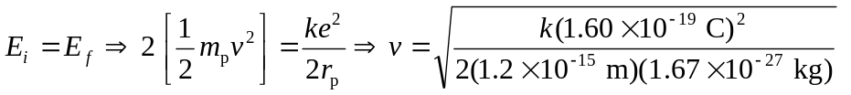
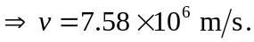

b) For a helium-helium collision, the charges and masses change from (a):
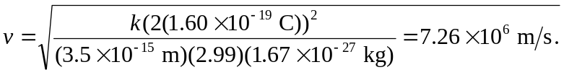
c) 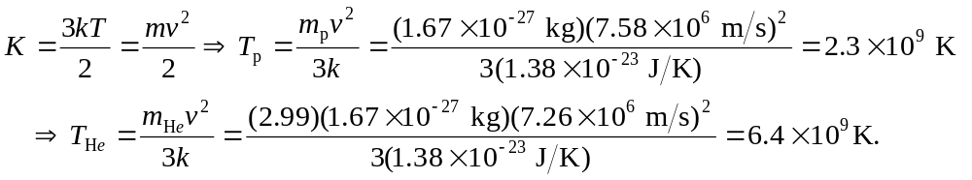

d) These calculations were based on the particles’ average speed. The distribution of speeds ensures that there are always a certain percentage with a speed greater than the average speed, and these particles can undergo the necessary reactions in the sun’s core.

